RESEARCH PAPER: SALES & PROFITABILITY ANALYSIS

TITLE:-
Product Line Profitability & Margin Performance Analysis for Nassau Candy Distributor

Abstract

This study presents a comprehensive data-driven analysis of product profitability, cost efficiency, and operational performance for the Nassau Candy Distributor. In highly competitive distribution environments, sales volume alone is insufficient to evaluate business success, as high-selling products may not necessarily contribute to overall profitability. This research aims to uncover hidden inefficiencies in product lines, divisions, and supply chain operations by leveraging exploratory data analysis (EDA) techniques.
The dataset comprises detailed transactional and logistical information, including sales, cost, units, product divisions, geographic regions, and factory locations. Key profitability metrics such as gross margin, profit per unit, and contribution ratios were derived to evaluate product and division-level performance. Data cleaning and validation ensured removal of inconsistent, zero-sales, and invalid profit records, while standardization improved analytical accuracy.
Product-level analysis revealed significant variation in profitability, identifying high-profit/high-margin products as well as high-sales/low-margin products indicating pricing inefficiencies. Division-level aggregation highlighted disparities in financial performance, with certain divisions demonstrating strong efficiency while others exhibited structural margin issues. Pareto (80–20) analysis confirmed that a small subset of products contributes disproportionately to total revenue and profit, indicating potential over-dependency risks.
Cost structure diagnostics using cost-versus-sales analysis identified cost-heavy, margin-poor products and exposed inefficiencies in pricing and sourcing strategies. Additionally, the integration of factory-location mapping enabled insights into production and logistics alignment across regions.
An interactive Streamlit dashboard was developed to visualize these insights, offering modules for product profitability, division performance, cost diagnostics, and profit concentration, along with user-driven filters for enhanced decision-making.
The findings provide actionable recommendations, including pricing optimization, cost reduction strategies, product portfolio rationalization, and risk diversification. Overall, this study demonstrates how data analytics can transform raw operational data into strategic intelligence, enabling improved profitability and sustainable business growth.

Introduction
In today’s competitive distribution landscape, organizations must move beyond traditional performance indicators such as sales volume to achieve sustainable profitability. For companies like Nassau Candy Distributor, relying solely on revenue figures can be misleading, as high sales do not always translate into strong financial performance. Certain products may generate significant revenue while contributing minimal profit due to high manufacturing, sourcing, or operational costs. As a result, understanding the true drivers of profitability has become critical for strategic decision-making.
This project focuses on analyzing product-level and division-level performance using detailed transactional and operational data. The dataset includes information on sales, cost, units sold, customer locations, shipping details, and product divisions, along with factory coordinates associated with different product lines. Such comprehensive data enables a multi-dimensional analysis of both financial and operational efficiency.
A key challenge faced by the organization is the lack of visibility into profitability drivers. Specifically, there is limited understanding of which products generate the highest margins, whether high-sales products are genuinely profitable, and how performance varies across divisions and regions. Additionally, the absence of structured insights makes it difficult to identify cost inefficiencies, pricing gaps, and underperforming product lines. This often results in reactive decision-making rather than strategic planning.
To address these challenges, this study employs exploratory data analysis (EDA) techniques combined with profitability metrics such as gross margin, profit per unit, and contribution ratios. The analysis is structured to evaluate product performance, compare division-level efficiency, and identify patterns of revenue and profit concentration using the Pareto principle. Furthermore, cost structure diagnostics are applied to detect products that are cost-intensive yet yield low margins, indicating the need for pricing adjustments or cost optimization.
Another important dimension of this study is the integration of supply chain insights through factory-product mapping. By linking products to their respective manufacturing locations, the analysis provides a deeper understanding of how production sources may influence cost structures and overall profitability.
The ultimate objective of this project is to transform raw business data into actionable insights that support strategic decisions. These include optimizing pricing strategies, improving cost efficiency, refining the product portfolio, and reducing dependency on a limited set of high-performing products. Additionally, an interactive dashboard is developed to enable real-time exploration of these insights, empowering stakeholders with data-driven decision-making capabilities.
Through this comprehensive approach, the study demonstrates the importance of combining financial analytics with operational intelligence to enhance business performance and maintain competitive advantage.

Dataset Description

The dataset used in this study contains detailed transactional, customer, product, and operational information for the Nassau Candy Distributor. It captures end-to-end order-level data, enabling comprehensive analysis of sales performance, cost structure, profitability, and supply chain operations.

1. Data Structure Overview
Each row in the dataset represents a single order transaction, containing information about:
- Order details
- Customer location
- Product and division
- Sales and cost metrics
- Logistics and shipping information
This multi-dimensional dataset supports both financial analysis and operational diagnostics.

2. Field-Level Description

Field Name | Description
Row ID | Unique identifier for each record
Order ID | Unique identifier for each order
Order Date | Date when the order was placed
Ship Date | Date when the order was shipped
Ship Mode | Shipping method used (e.g., standard, express)
Customer ID | Unique identifier for each customer
Country/Region | Country or region of the customer
City | Customer’s city
State/Province | Customer’s state or province
Postal Code | Customer’s postal/zip code
Region | Broader geographic region classification
Division | Product category (e.g., Chocolate, Sugar, Other)
Product ID | Unique identifier for each product
Product Name | Full name/description of the product
Sales | Total revenue generated from the order
Units | Number of units sold in the order
Cost | Cost incurred to manufacture or procure the product
Gross Profit | Profit earned from the order (Sales – Cost)

3. Derived Variables (Engineered Features)
To enhance analytical depth, additional variables were computed:
✔ Gross Margin (%)
$$\text{Gross Margin}=\frac{\text{Gross Profit}}{\text{Sales}}×100$$
✔ Profit per Unit
$$\text{Profit per Unit}=\frac{\text{Gross Profit}}{\text{Units}}$$
✔ Revenue Contribution
$$\text{Product Sales}÷\text{Total Sales}$$
✔ Profit Contribution
$$\text{Product Profit}÷\text{Total Profit}$$
These metrics are essential for evaluating efficiency, profitability, and product performance.

4. Factory and Supply Chain Data
The dataset is enriched with factory location data, linking products to their manufacturing sources.
Factory Coordinates
Factory | Latitude | Longitude
Lot's O' Nuts | 32.881893 | -111.768036
Wicked Choccy's | 32.076176 | -81.088371
Sugar Shack | 48.11914 | -96.18115
Secret Factory | 41.446333 | -90.565487
The Other Factory | 35.1175 | -89.971107

Product–Factory Mapping
Products are mapped to factories based on division:
- Chocolate Products → Manufactured at:
  - Lot's O' Nuts
  - Wicked Choccy's
- Sugar Products → Manufactured at:
  - Sugar Shack
  - Secret Factory
  - The Other Factory
- Other Products → Distributed across:
  - Secret Factory
  - The Other Factory

5. Data Granularity
- Level: Order-level (transactional data)
- Time Dimension: Includes order and shipment dates
- Geographical Dimension: Region, state, city-level
- Product Dimension: Product, division, factory

6. Data Relevance for Analysis
This dataset enables:
✔ Product-level profitability analysis
✔ Division-wise performance comparison
✔ Cost vs sales diagnostics
✔ Pareto (80–20) analysis
✔ Regional demand and distribution analysis
✔ Supply chain and factory-level insights

Data Cleaning & Preprocessing
High-quality data is essential for accurate analysis and reliable insights. The raw dataset obtained from the Nassau Candy Distributor contained inconsistencies, missing values, and potential anomalies that required systematic preprocessing. The following steps were performed to ensure data integrity and analytical readiness.

1 Handling Missing Values
Missing values were identified in key fields such as:
Sales
- Cost
- Units
Actions Taken:
- Rows with missing sales or cost values were removed, as these are critical for profitability calculations
- Missing units values were handled by:
  - Either imputing with median values (if minimal)
  - Or removing records where units were essential

2 Data Validation
To ensure logical consistency, the dataset was validated for:
Non-negative Values:
- Ensured Sales ≥ 0
- Ensured Cost ≥ 0
Profit Consistency:
- Verified:
$$\text{Gross Profit}=\text{Sales}-\text{Cost}$$
Removal of Invalid Records:
- Records with:
  - Negative values
  - Inconsistent profit calculations
  - Zero or unrealistic sales
were removed.

3 Handling Zero and Invalid Records
Special attention was given to:
Zero Sales Records:
- Removed entries where:
  - Sales = 0
- As these do not contribute to revenue analysis
Invalid Profit Records:
- Removed records where:
  - Profit is zero or negative (based on analysis requirement)

4 Standardization of Data
To ensure consistency across categories:
Column Standardization:
- Converted all column names to lowercase
- Removed extra spaces
Categorical Cleaning:
- Standardized:
  - Division names (e.g., “Chocolate”, “Sugar”, “Other”)
  - Product names (removed inconsistencies and duplicates)

5 Date Formatting
Date columns were converted into proper datetime format:
- Order Date
- Ship Date
Actions:
- Converted to datetime format
- Extracted:
  - Month
  - Year
  - Order-to-ship duration (optional KPI)

6 Feature Engineering
New variables were created to enhance analysis:
✔ Total Profit
$$\text{Total Profit}=\text{Sales}-\text{Cost}$$
✔ Gross Margin (%)
$$\text{Gross Margin}=\frac{\text{Total Profit}}{\text{Sales}}×100$$
✔ Profit per Unit
$$\text{Profit per Unit}=\frac{\text{Total Profit}}{\text{Units}}$$
Contribution Metrics:
- Revenue contribution
- Profit contribution

7 Outlier Detection
Outliers were identified using:
- Statistical thresholds (mean ± standard deviation)
- Visualization (box plots, scatter plots)
Handling:
- Extreme outliers were either:
  - Investigated
  - Or removed if found erroneous

8 Data Integrity Check
Final validation ensured:
✔ No missing critical values
✔ Correct profit calculations
✔ Consistent categorical values
✔ Clean and analysis-ready dataset

Exploratory Data Analysis (EDA)
Exploratory Data Analysis (EDA) was conducted to uncover patterns, trends, and relationships within the dataset of the Nassau Candy Distributor. The analysis focuses on understanding product-level profitability, division performance, cost efficiency, and revenue concentration.

1 Overall Business Performance
Key Metrics Evaluated:
- Total Sales
- Total Cost
- Total Profit
- Average Gross Margin
Observations:
- The dataset shows a wide variation in sales and cost values across products
- Profit margins vary significantly, indicating inconsistent profitability
Interpretation:
- The business does not have uniform pricing or cost structures
- Some products contribute disproportionately to overall profit

2 Product-Level Profitability Analysis
Products were analysed based on:
- Total Profit
- Gross Margin (%)
- Sales vs Margin
Analysis Performed:
- Ranking products by profit and margin
- Identifying top and bottom performers
Observations:
✔ A small number of products generate the highest profit
✔ Some products show:
- High sales but low margins
- Low sales and low profit

Total Profit:
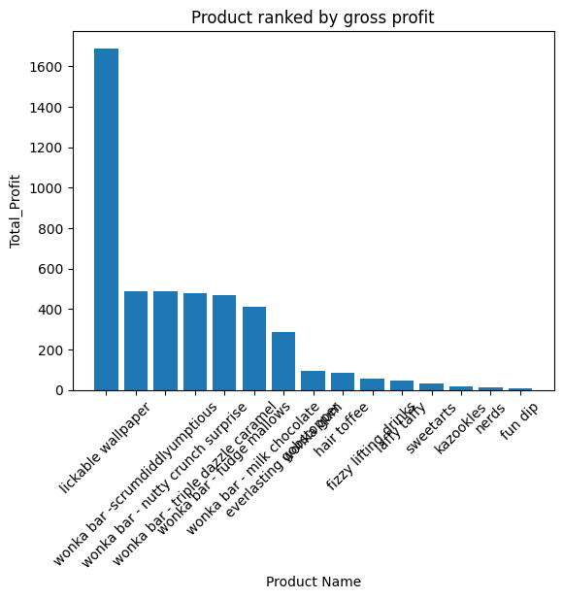

Gross Margin(%):
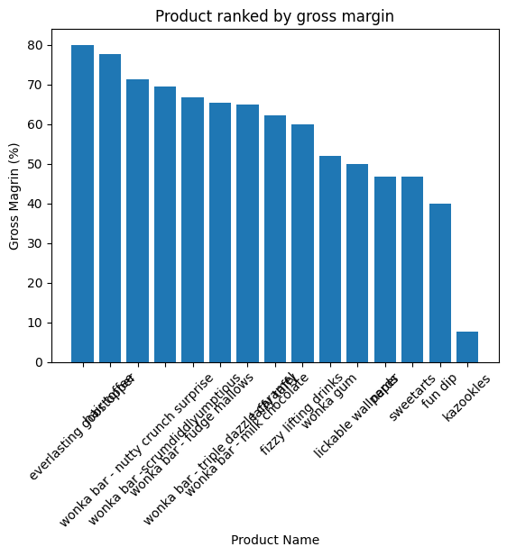
Sales VS Margin:
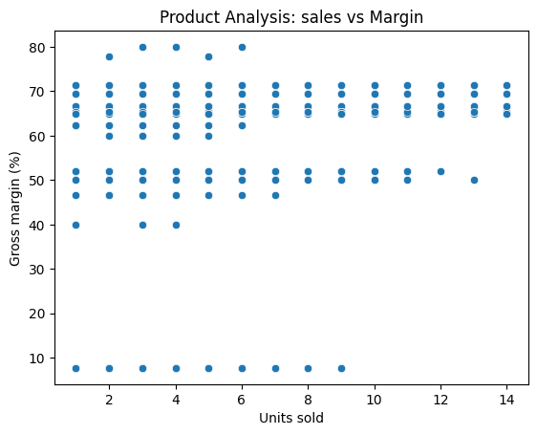
3 Division-Level Performance Analysis
Data was aggregated by Division (Chocolate, Sugar, Other).
📊 Metrics Compared:
- Total Revenue
- Total Profit
- Average Margin
Observations:
✔ Some divisions generate high revenue but relatively lower profit
✔ Certain divisions maintain consistent and higher margins

Total Profit :
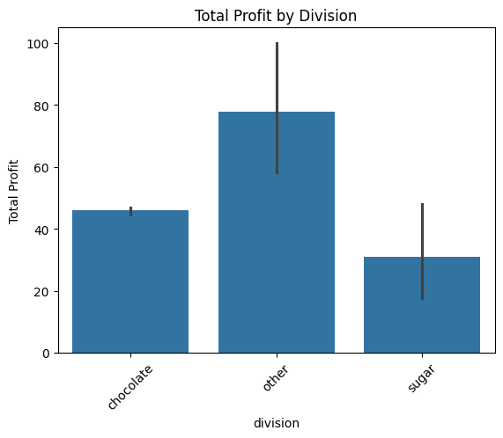

Average Margin:
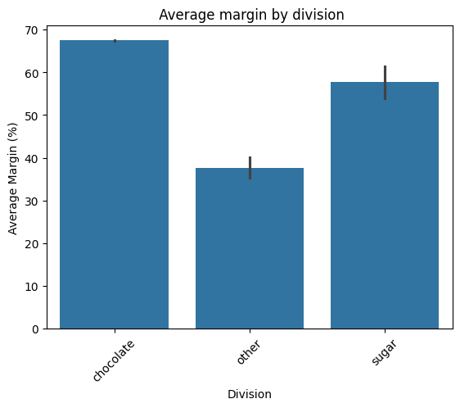
Revenue VS Profit:
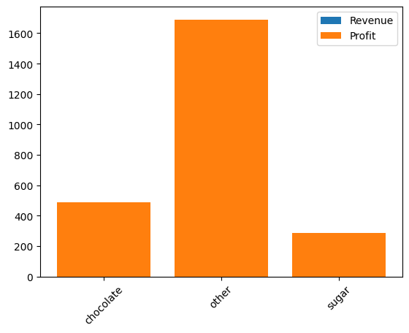
5 Cost Structure Diagnostics
A scatter analysis of Cost vs Sales was conducted.

Cost vs sales scatter analysis:
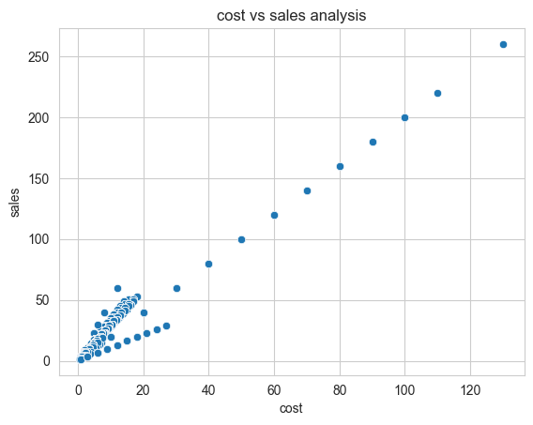
6 Pricing Inefficiency Detection
Products with:
- High sales
- Low margins
were identified as pricing inefficiencies.
Observations:
- These products are popular but not profitable enough
Interpretation:
- Pricing strategy needs adjustment
- Opportunity to increase profit without losing demand

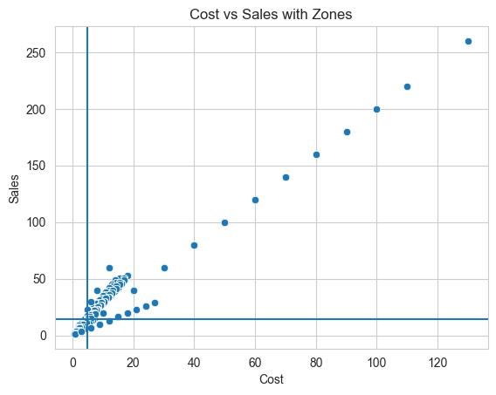

7 Pareto Analysis (80–20 Principle)
Pareto analysis was performed to evaluate contribution of products to total revenue and profit.

Observations:
✔ Approximately 20–30% of products contribute to ~80% of revenue
✔ Similar trend observed for profit

Interpretation:
- Business is highly dependent on a small number of products
- Indicates concentration risk

Revenue Pareto Chart:
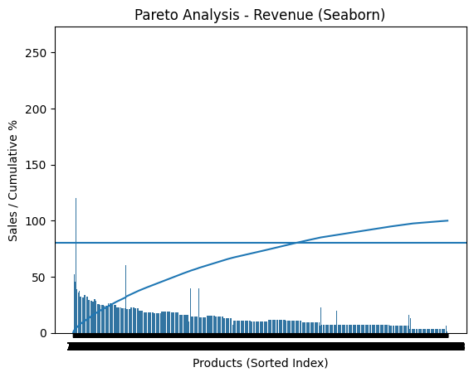
Profit Pareto Chart:
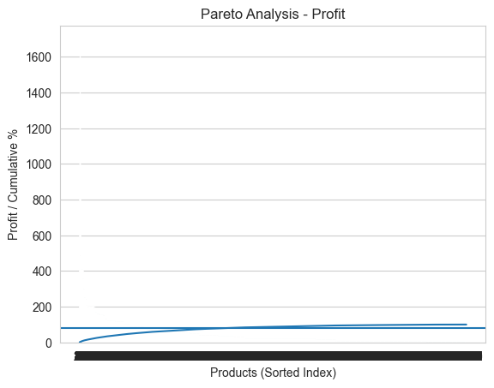
key Insights
High-Performance Products
- High profit and high margin
- Key contributors to business success
Cost-Heavy Products
- High cost, low profitability
- Reduce overall efficiency
Pricing Inefficiencies
- High sales but low margin
- Opportunity for price optimization
Over-Dependency Risk
- Revenue concentrated in few products
- Risk if demand for these products drops

Recommendations

1. Focus on High-Performing Products
- Increase marketing and inventory
- Expand product availability

2. Optimize Cost Structure
- Negotiate supplier pricing
- Improve operational efficiency

3. Implement Pricing Strategy
- Increase prices for high-demand products
- Maintain competitive pricing
4. Product Portfolio Optimization
- Discontinue low-performing products
- Improve or reposition weak products
🛡 5. Reduce Business Risk
- Diversify product portfolio
- Reduce reliance on top-performing products

Dashboard Implementation
An interactive dashboard was developed using Streamlit with:
✔ Modules:
- Product profitability overview
- Division performance analysis
- Cost diagnostics
- Pareto analysis
✔ User Controls:
- Division filter
- Margin threshold slider
- Product search
- Date range filter

StreamLit Dashboard Image:

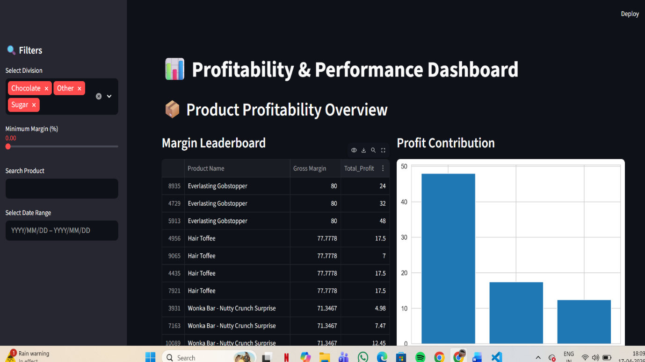

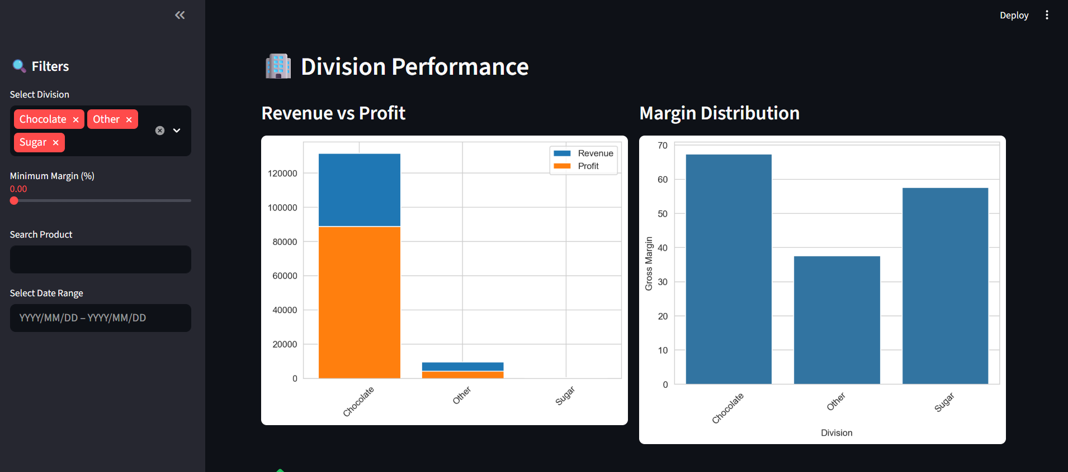
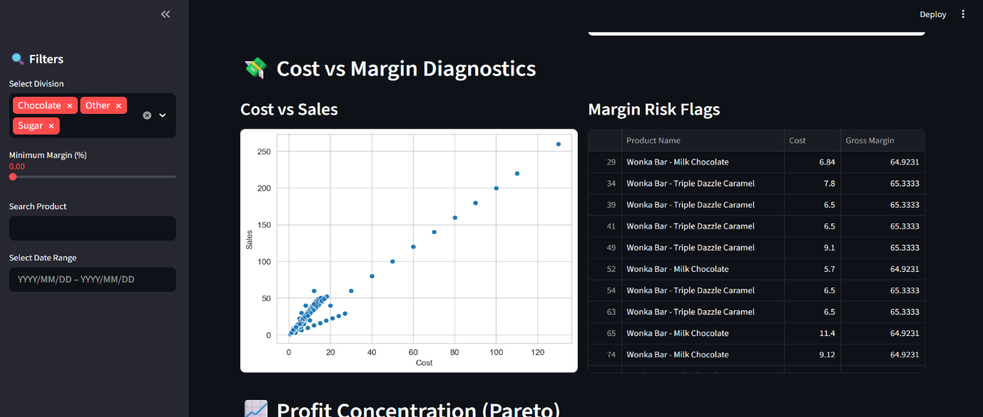

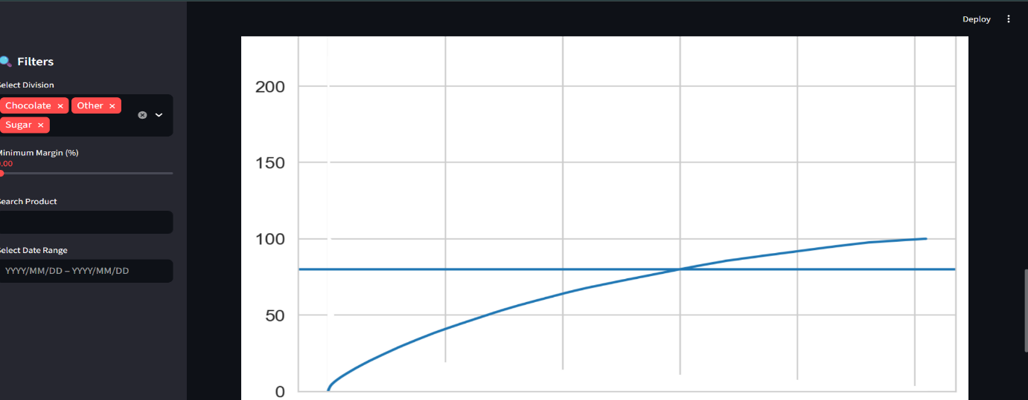

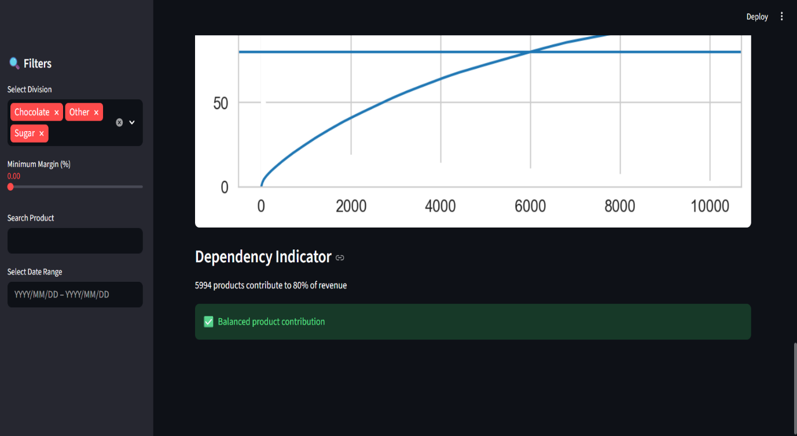
Conclusion
This study provides a comprehensive analysis of product profitability, cost efficiency, and operational performance for the Nassau Candy Distributor using exploratory data analysis (EDA) techniques. The findings clearly demonstrate that relying solely on sales volume as a performance indicator can be misleading, as high-revenue products do not always translate into high profitability.
The analysis revealed that a limited number of products contribute disproportionately to total revenue and profit, confirming the presence of the Pareto (80–20) principle. This concentration indicates a potential business risk, as over-dependence on a small subset of products can impact stability if demand fluctuates. At the same time, several products were identified as high-sales but low-margin, highlighting significant pricing inefficiencies that require immediate attention.
Division-level analysis further exposed disparities in financial performance, with some divisions demonstrating strong margin efficiency while others suffer from structural cost challenges. Cost diagnostics emphasized the presence of cost-heavy, margin-poor products, suggesting the need for cost optimization, supplier renegotiation, and process improvements. Additionally, the integration of product-to-factory mapping provided valuable insights into how sourcing and manufacturing locations may influence cost structures and overall profitability.
The development of an interactive Streamlit dashboard enhances the practical applicability of this study by enabling real-time exploration of key metrics such as product profitability, division performance, cost diagnostics, and profit concentration. This tool supports informed, data-driven decision-making for stakeholders.
Overall, this project highlights the importance of combining financial analysis with operational insights to achieve sustainable business growth. By implementing the recommended strategies—such as pricing optimization, cost reduction, product portfolio rationalization, and risk diversification—the organization can significantly improve its profitability and competitive positioning. The study demonstrates that data analytics can effectively transform raw business data into actionable intelligence, driving smarter and more strategic decisions.

